EXPERIMENT – 7

Name:RAHUL GOEL

Reg no: RA1911030010094

AIM: Finding a factorial of a 8 bit numbers

Software used: EMU8086

Coding :

data segment

A db 04h

B db 01h

data ends

code segment

assume cs:code,ds:data

start:

mov ax,data

mov ds,ax

mov cl,A

mov al,B

loop:

mul cl :/MUL-store and multiply

dec cl :/DEC-Decrement by 1

jnz loop :/JNZ-(not equal to zero)

int 3

code ends

end start

Coding in EMU8086:

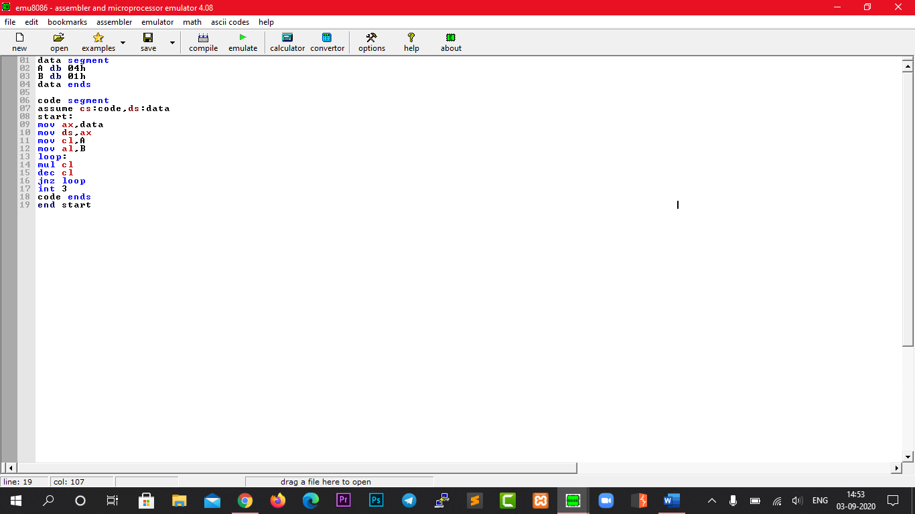

Output in EMU8086:

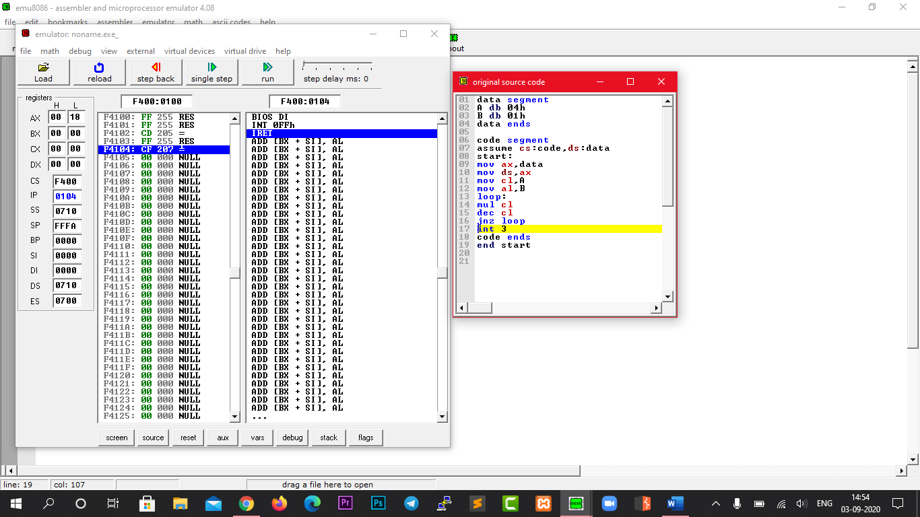

AX value as 18

Result:

The factorial of 8-bit numbers have been done using the emulator.